Introduction to Databases

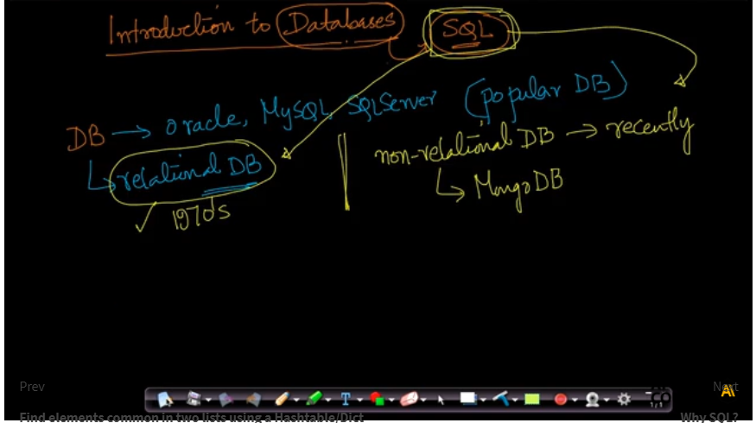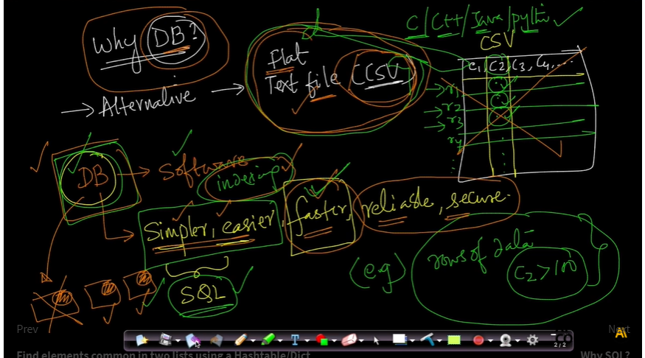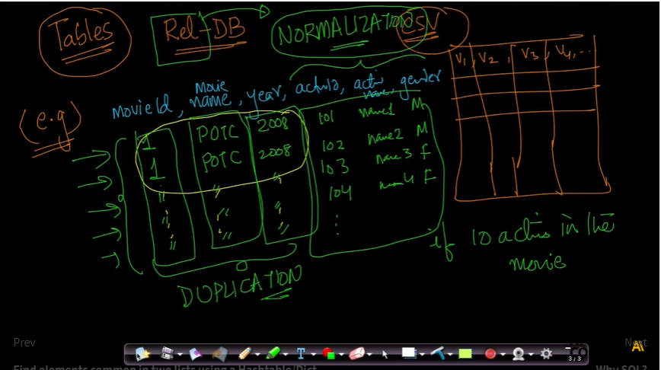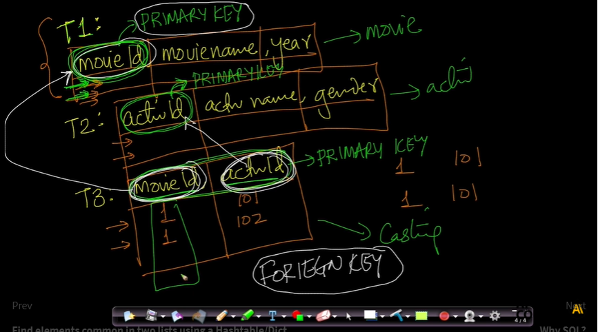

[Why SQL?](https://beta.appliedaicourse.com/lecture/11/applied-machine-learning-online-course/3476/why-sql/1/module-1-fundamentals-of-programming)

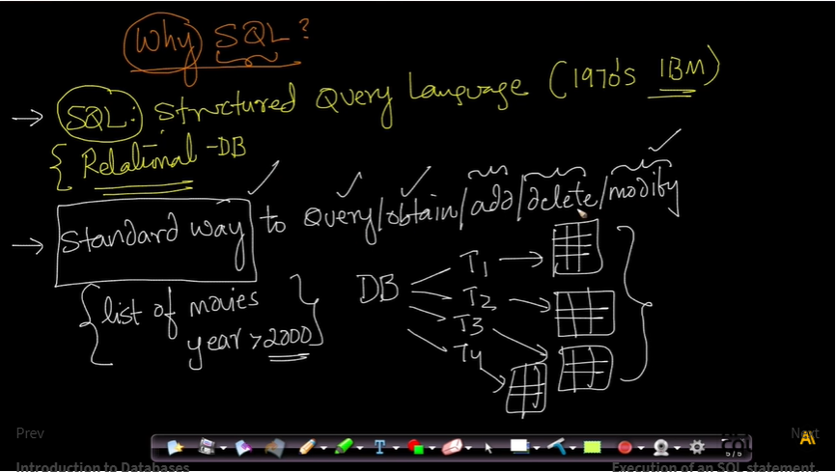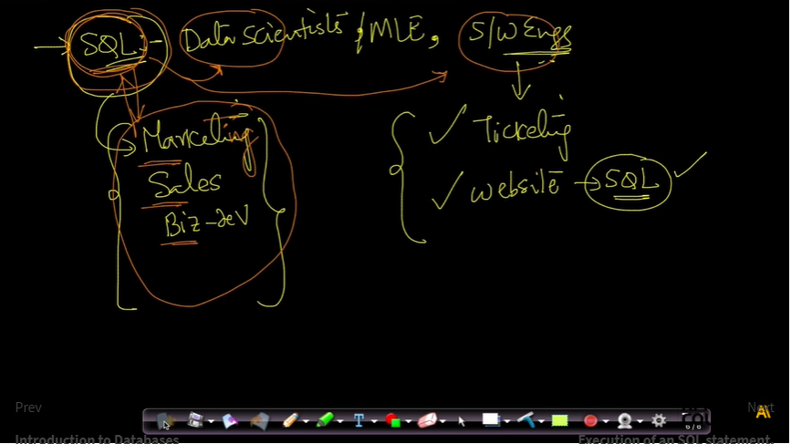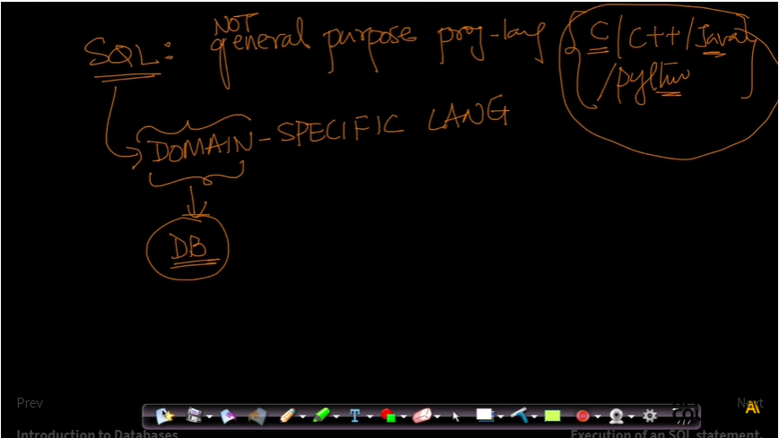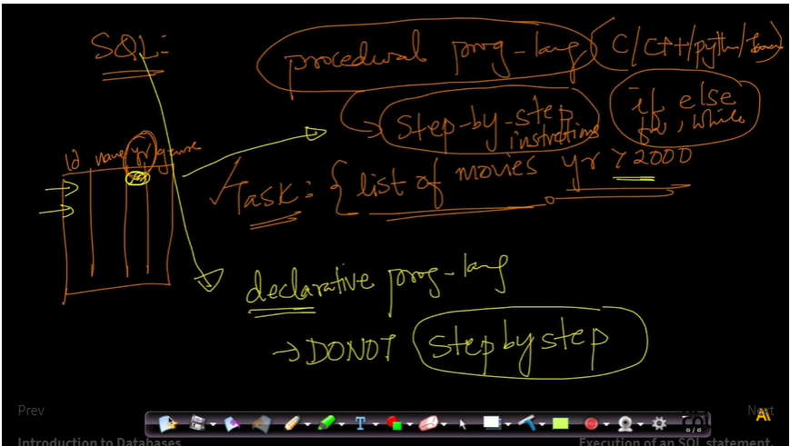

[Execution of an SQL statement.](https://beta.appliedaicourse.com/lecture/11/applied-machine-learning-online-course/3477/execution-of-an-sql-statement/1/module-1-fundamentals-of-programming)

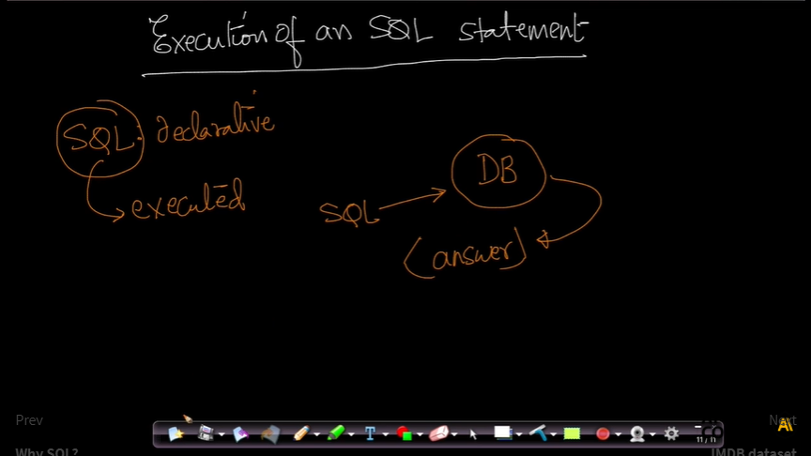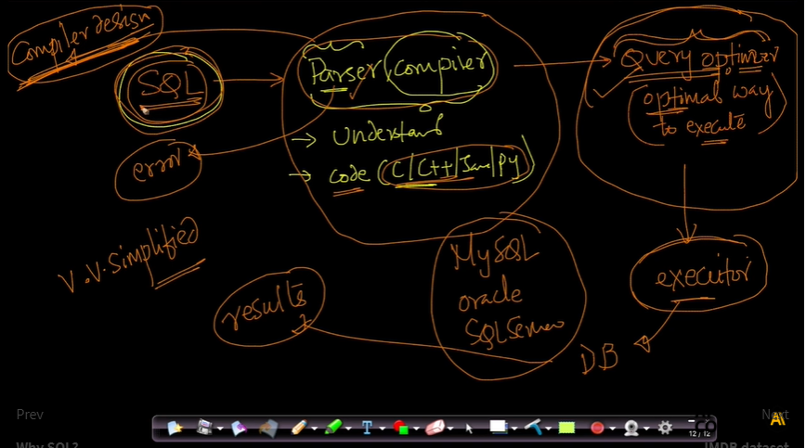

[IMDB dataset](https://beta.appliedaicourse.com/lecture/11/applied-machine-learning-online-course/3478/imdb-dataset/1/module-1-fundamentals-of-programming)

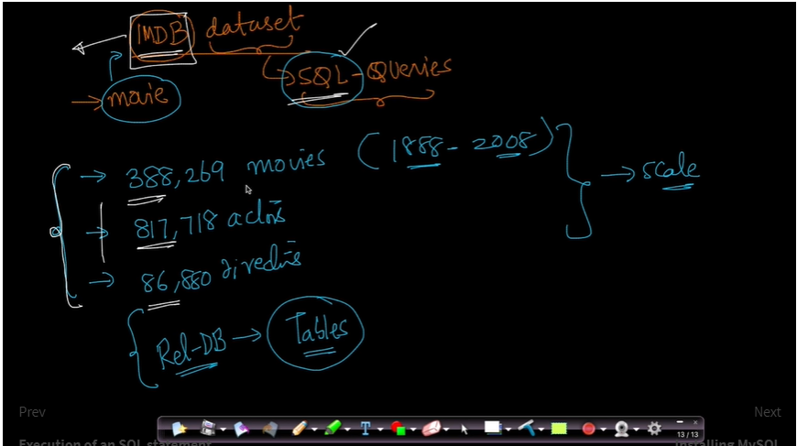

[SELECT](https://beta.appliedaicourse.com/lecture/11/applied-machine-learning-online-course/3482/select/1/module-1-fundamentals-of-programming)

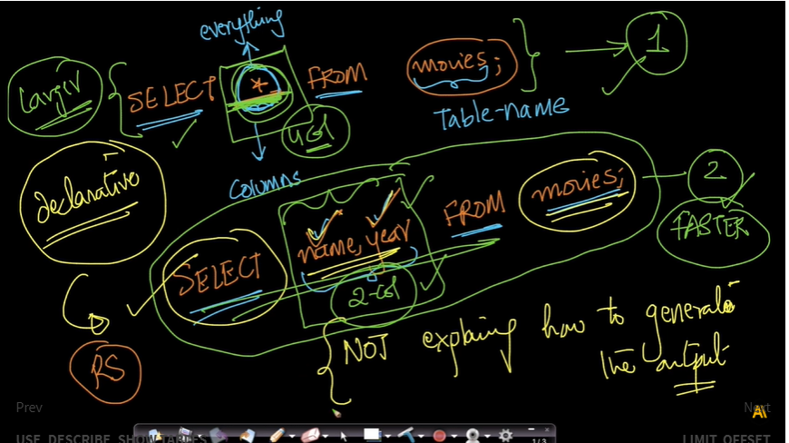

[LIMIT, OFFSET](https://beta.appliedaicourse.com/lecture/11/applied-machine-learning-online-course/3483/limit-offset/1/module-1-fundamentals-of-programming)

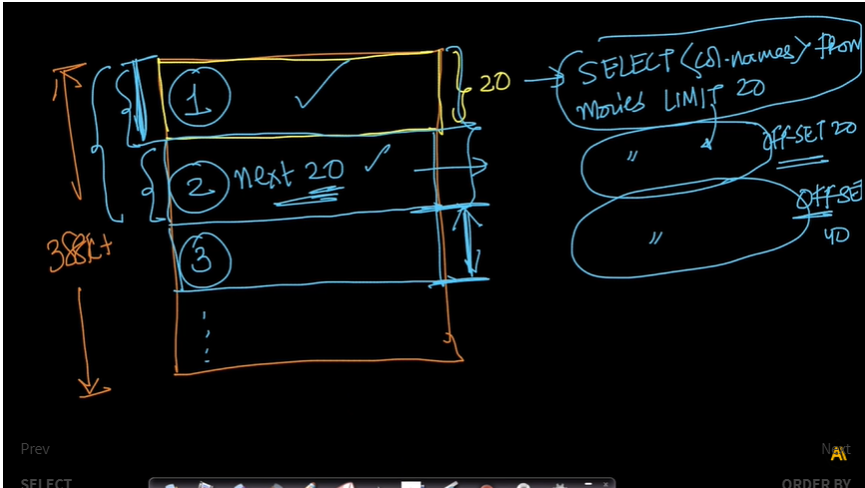

[Inner, Left, Right and Outer joins.](https://beta.appliedaicourse.com/lecture/11/applied-machine-learning-online-course/3493/inner-left-right-and-outer-joins/1/module-1-fundamentals-of-programming) 